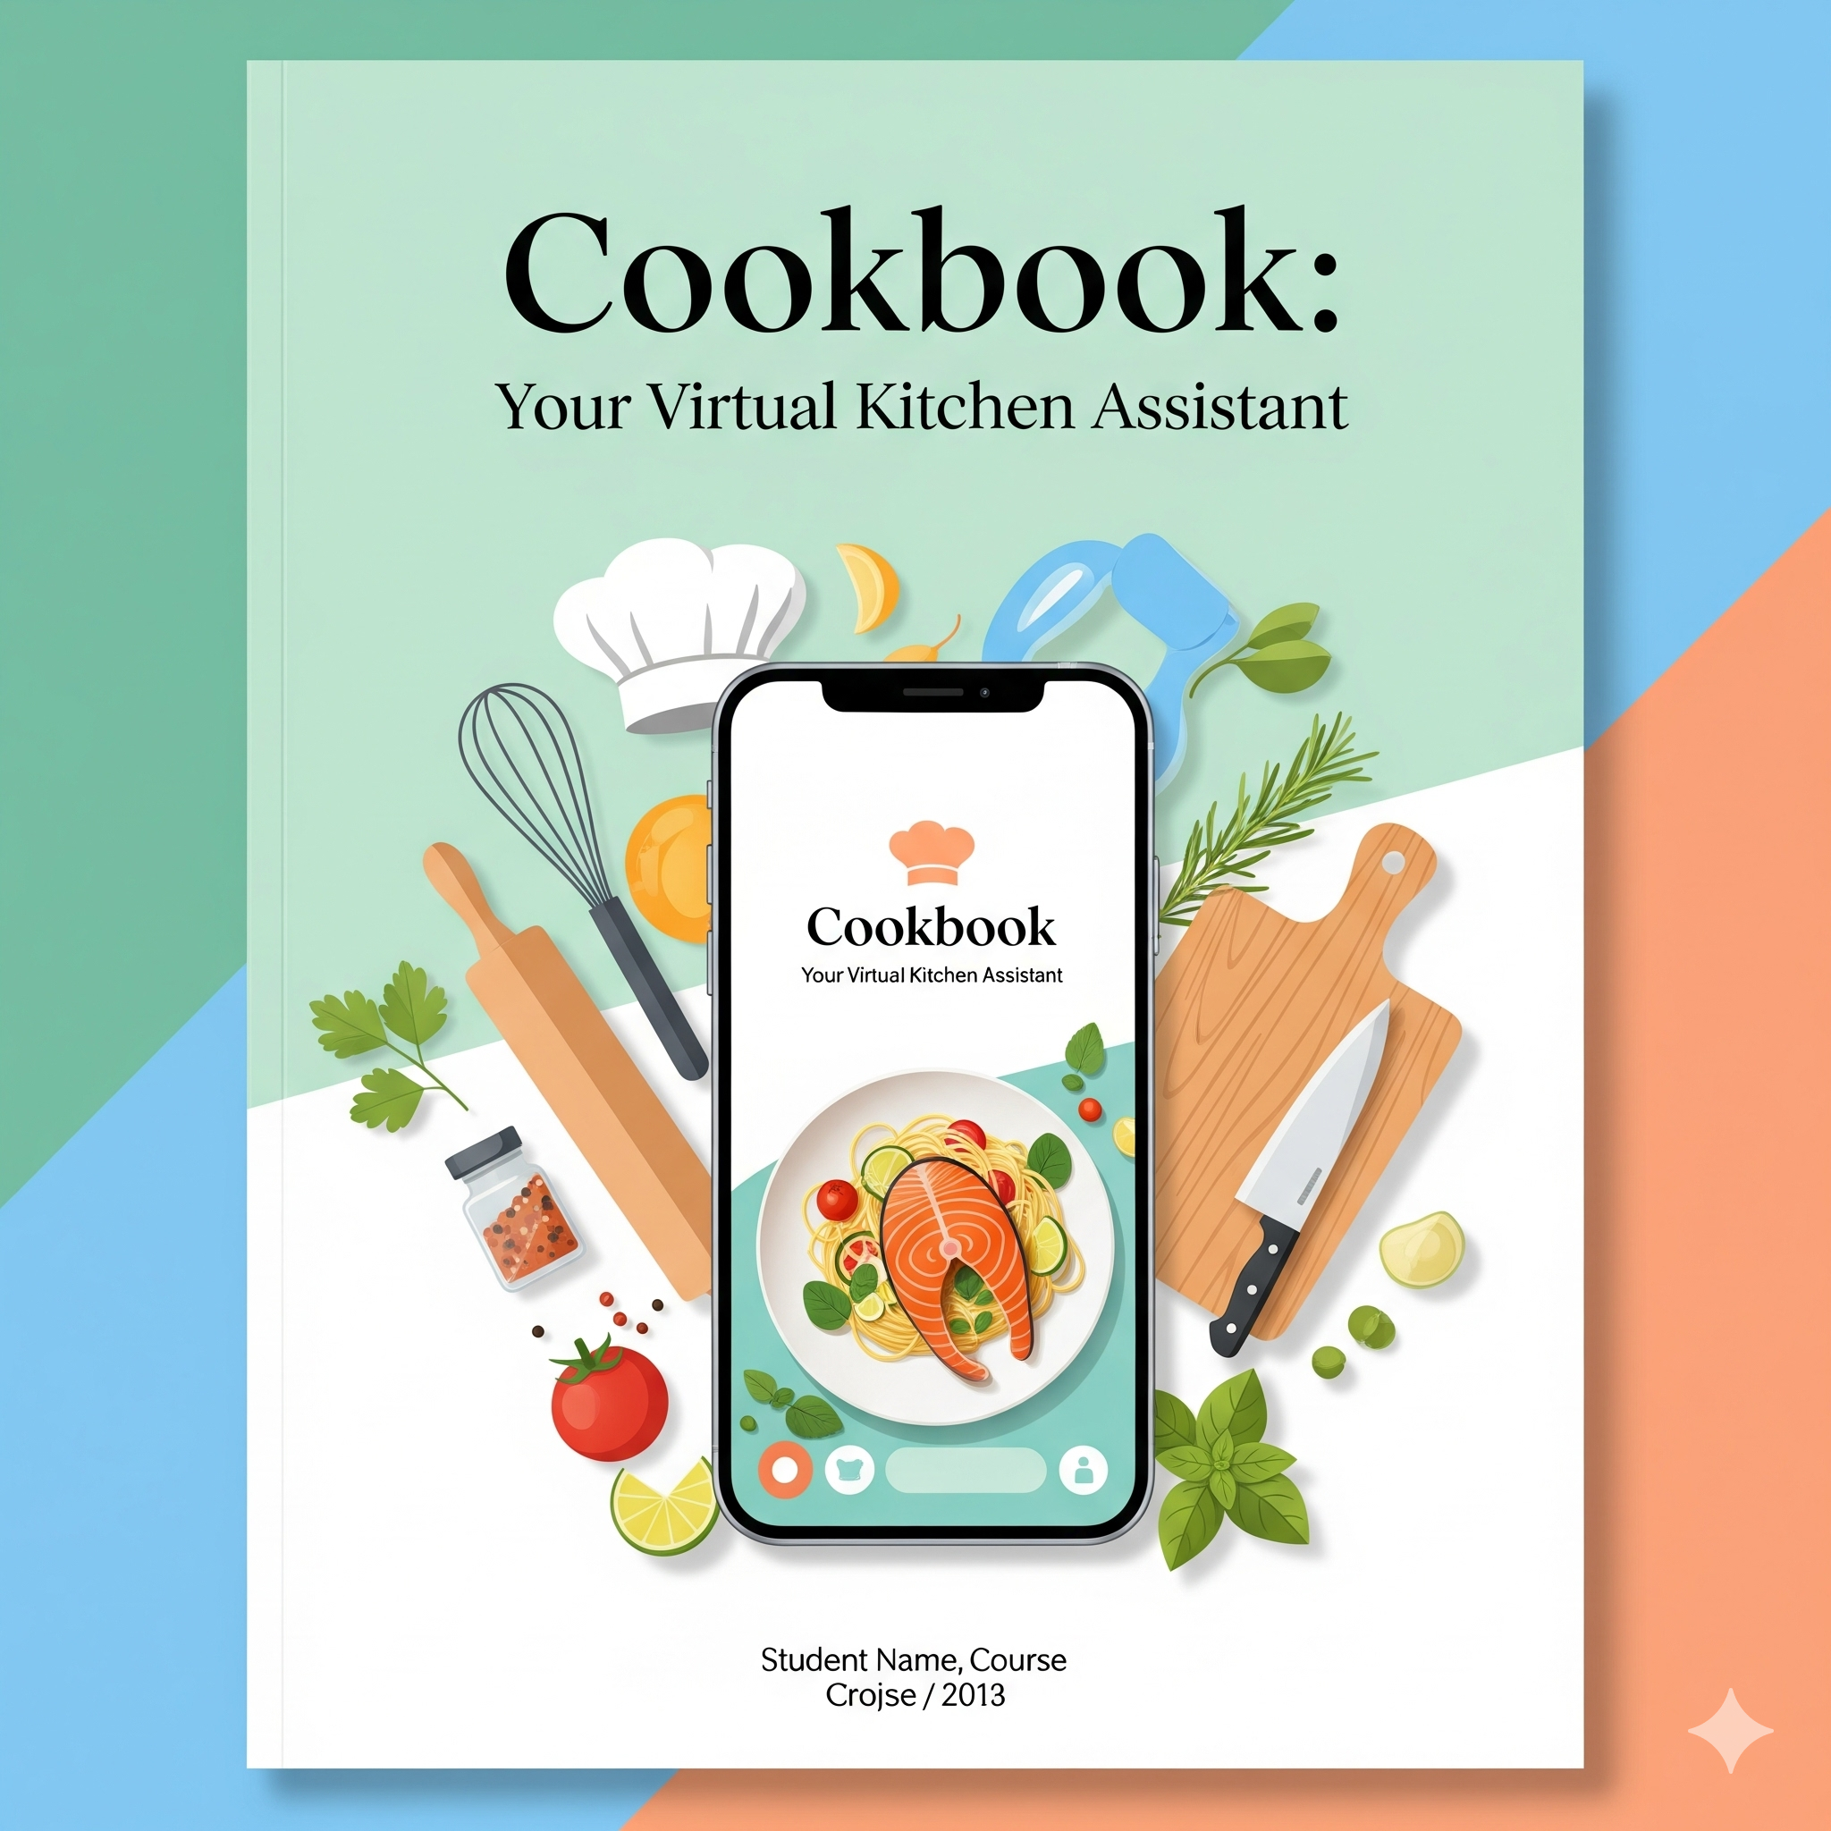

# **INTRODUCTION:**

# **Project Title** : Cookbook:

# Your Virtual Kitchen Assistant.

# **Team Id: NM2025TMID37033 (nirnik)**

# **Team Leader: Nirbica.P.Y &** [**nirbica2506@gmail.com**](mailto:nirbica2506@gmail.com)

# **Team Members:**

* Nikhisha.A & [nikhishaaraa@gmail.com](mailto:nikhishaaraa@gmail.com)
* Anish.V &

[venuani54@gmail.com](mailto:venuani54@gmail.com)

* Noorul Nasrien.T &

[najeebubanu@gmail.com](mailto:najeebubanu@gmail.com)

# **PROJECT OVERVIEW:**

# **Purpose:**

# Cookbook is an interactive platform designed to assist users in meal planning ,recipe discovery,ingredient management and step-by-step cooking guidance using virtual assistant features.

# **Features:**

# . Recipe search and recommendation.

# Meal planner and grocery list generator.

# Step-by-step cooking instructions.

# Ingredient substitution and dietary filtering.

# Interactive chat-based kitchen assistance.

# **ARCHITECTURE:**

# **Frontend:**React.js with Bootstrap and Material UI for intuitive user interface.

# **Backend:**Node.js and Express.js to manage server logic and API endpoints.

# **Database:**MongoDB to store user data,recipes,meal plans,shopping list and chat history.

# **SETUP INSTRUCTIONS:**

# **Prerequisites:**

# Node.js

# MongoDB

# Git

# Basic JS

# Express.js

# Mongoose

# Visual Studio Code

# Installation Steps:

# 1.Clone the repository:

# text

## git clone<repo-url>

# 2.Install client dependencies:

# text

## cd client

## npm install

# 3.Install server dependencies:

# text

## cd server

## npm install

# **FOLDER STRUCTURE**:

# Cookbook/

# ├── client/ # React frontend

# │ ├── components/

# │ ├── pages/

# ├── server/ # Node.js backend

# │ ├── models/

# │ ├── controllers/

# │ ├── routes/

# **RUNNING THE APPLICATION:**

# Frontened:

# text

## cd client

## npm start

# Backend:

# Text

## cd server

## npm start

# **API DOCUMENTATION:**

# User:

# /api/user/register

# /api/user/login

# Recipes:

# /api/recipes/search

# /api/recipes/favourite

# Meal Plans:

# /api/mealplan/create

# /api/mealplan/userid

# Chat Assistant:

# /api/chat/send

# /api/chat/history

# **AUTHENTICATION:**

# **JWT-based authentication** for secure login.

# Middleware protects private routes.

* **Role-Based Access Control (RBAC)**.
* **Password Hashing & Encryption:** User credentials are stored securely using hashing algorithms

# **USER INTERFACE:**

# Landing Page(intro, feature highlights)

# Recipe Explorer

# Meal Planner

# Grocery list Page

# Virtual Assistant Chat

# Profile&Preferences

# **TESTING:**

# Manual testing during milestones

# Tools:Postman,Chrome Dev Tools

# **SCREENSHOTS:**

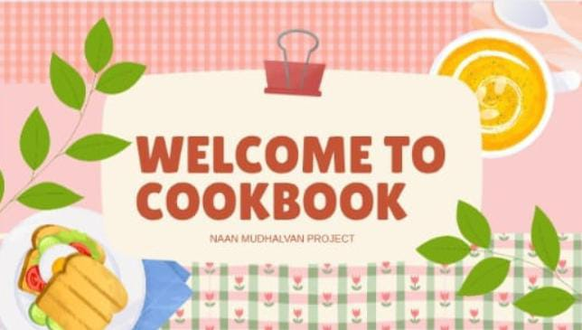

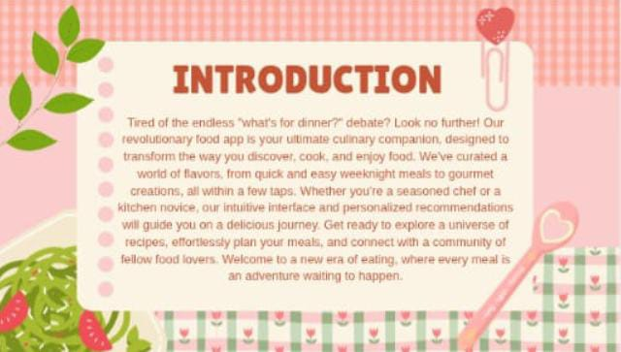

# 

# 

# 

# 

# 

# 

# 

# 

# 

# 

# 

# **KNOWN ISSUES:**

# Document any bugs,feature limitations or performance bottlenecks

# **FUTURE ENHANCEMENTS**:

# Integration with smart Kitchen devices.

# Adavnced voice assistant features.

# Social recipe sharing.

# Personalized nutrition recommendation.

“Let medicine be thy food and food be thy medicine”